SIMATS ENGINEERING
ASSESSMENT TOOL 1

COURSE CODE: CSA1402 COURSE NAME: Compiler Design

COURSE OUTCOME COVERED

CO4: Examine intermediate code generation techniques to enhance code optimization (BL4)

Assessment Tool Weightage: 40%

QUESTIONS: 5 Total Marks:50

Annexure A

CLASS TEST

Code of Conduct:

I GAUTHAM B 192421318 (Name / Reg No) certify that this submission is my original work and that I have adhered to the guidelines specified for this assessment.
I understand that any violation of academic integrity rules will result in disciplinary action.

Signature of the student: GAUTHAM.B

Q. No | Understanding of Concepts (25) | Explanation (25) | Application (20) | Organization(15) | Accuracy(10) | Total Score  (out of 100)
1 | / 4 | / 4 | / 4 | / 4 | / 4
2 | / 4 | / 4 | / 4 | / 4 | / 4
3 | / 4 | / 4 | / 4 | / 4 | / 4
4 | / 4 | / 4 | / 4 | / 4 | / 4
5 | / 4 | / 4 | / 4 | / 4 | / 4
OVERALL RUBRICS VALUE
 | / 4 | / 4 | / 4 | / 4 | / 4
 | / 25 | / 30 | / 20 | / 15 | / 10 | / 100

Annexure A

CLASS TEST

Q1. Construct three address code for the following
if((a < b) and ((c < d) or (a > d))) then
z=x + y *z
else
z = z + 1

Q2.Translate (a < b) and (c < d) or (e < f) into three address statements using back patching.

Q3. Consider the arithmetic expression:
A = (- A + B) * ((- A + B) * C)
(i).Analyze the given expression and explain how operator precedence and associativity influence its evaluation order.
(ii). Construct the Three Address Code (TAC) for the expression by breaking it into intermediate steps using temporary variables.
(iii). Represent the generated TAC in the following forms:
(a).Quadruples (op, arg1, arg2, result)
(b).Triples (index, op, arg1, arg2)
(c).Indirect Triples (pointer-based representation)
(iv). Compare the representations and analyze:
(a).Memory usage
(b).Ease of code optimization
(c).Advantages of indirect triples over triples

Q4. Construct three address code using the following production for Boolean expression (a > b) or (c < d) or (e < f)
B → B1 || B2
B → B1 && B2
B → ! B1
B → E1 relop E2
B → true
B → false

Q5. Generate the three address code for the following program fragment-
while (A < C and B > D) do
if A = 1 then C = C + 1
else while A < = D do
A = A + B

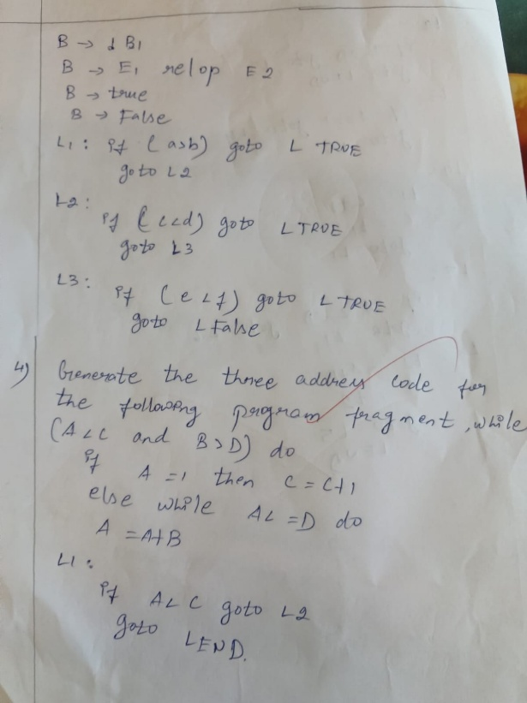
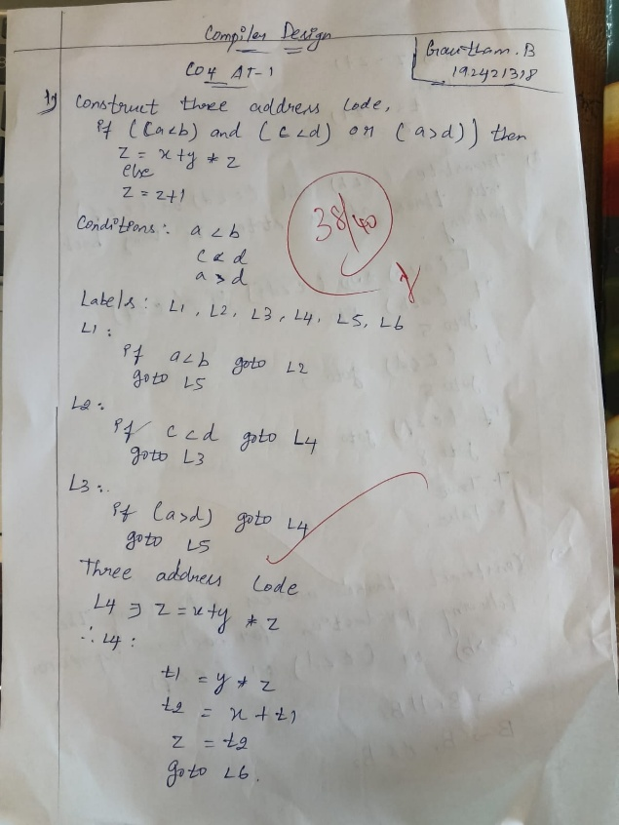

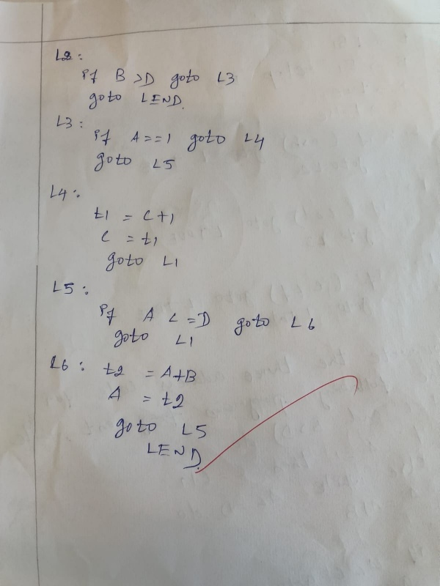
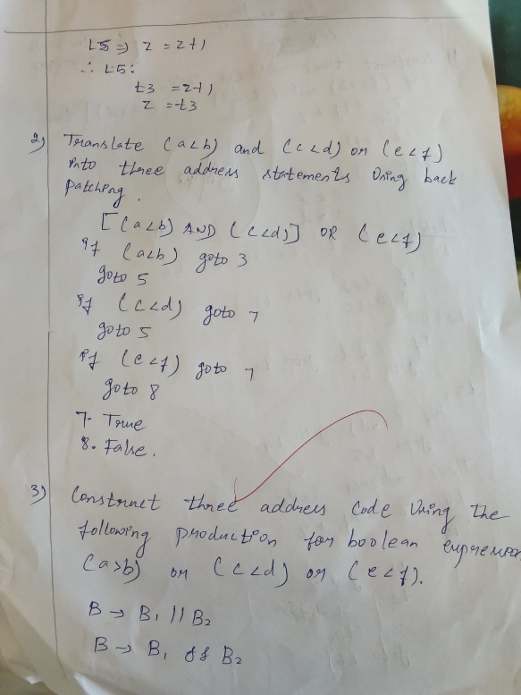

RUBRICS FOR CALCULATION

Criteria | Weightage | Level 4 – Exemplary | Level 3 – Proficient | Level 2 – Developing | Level 1 – Beginning
Understanding of Concepts | 25% | Demonstrates thorough, accurate understanding of concepts | Good understanding with minor gaps | Basic understanding with some misconceptions | Poor understanding; major misconceptions
Explanation | 25% | Detailed, well-explained answers with relevant examples | Clear explanation with adequate details | Limited explanation; lacks depth | Poor or unclear explanation
Application | 20% | Effectively applies concepts with strong analytical ability | Applies concepts with minor errors | Limited application with weak analysis | No application or incorrect analysis
Organization | 15% | Well-structured answers with logical flow and coherence | Organized with minor issues in flow | Basic structure, lacks clarity | Poor organization, incoherent answers
Accuracy | 15% | Completely accurate and covers all required points | Mostly accurate with minor omissions | Partially correct with missing points | Incorrect answers with major gaps

